See output screenshots for SSH_Barrage, Linux Stress, and wget-DoS below.

SSH_Barrage.sh and wget-DoS.sh scripts are in the Linux Folder on Github

SSH Barrage Log Output

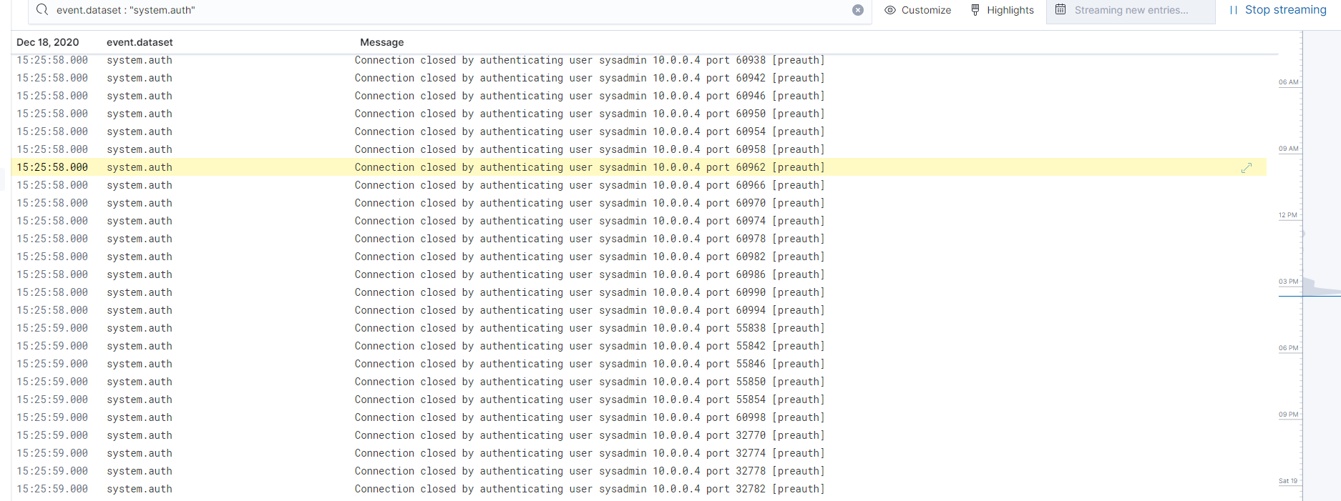

Linux Stress Metrics:

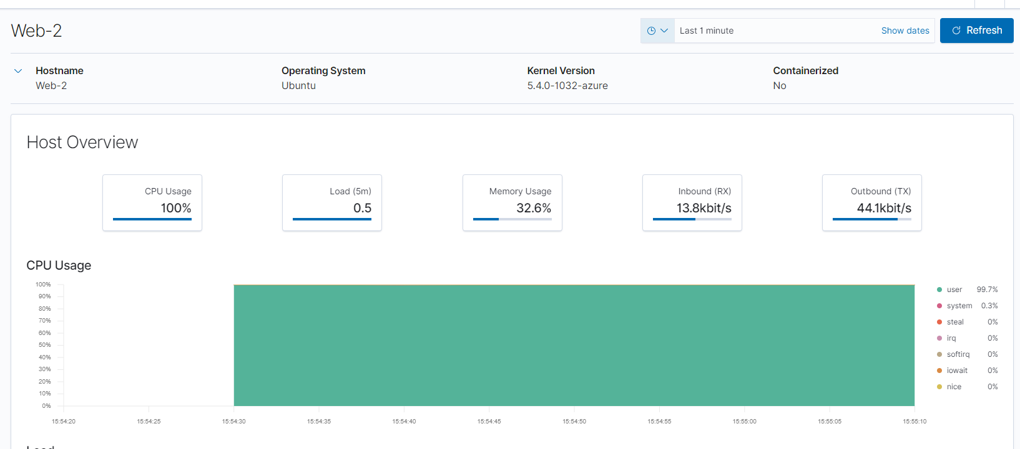

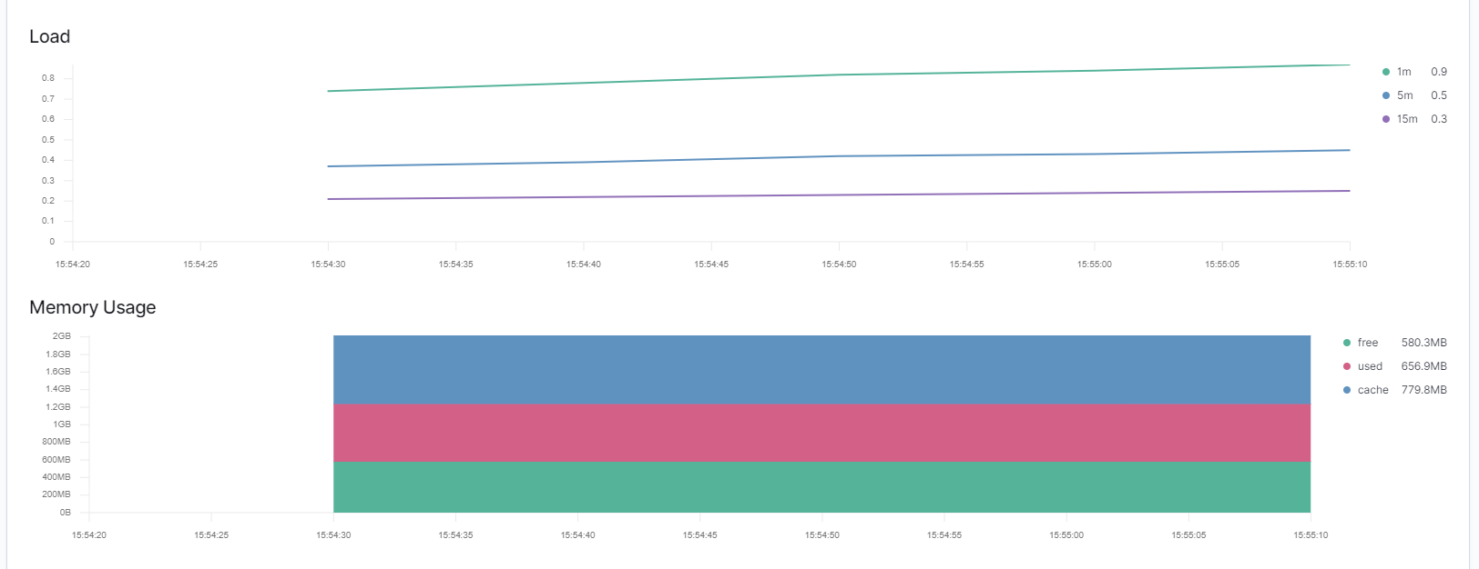

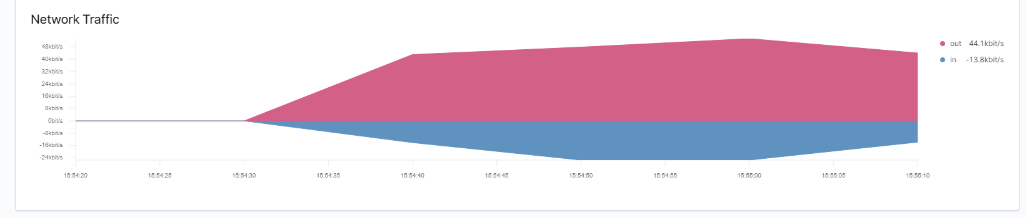

wget-DoS Requests:

